Dear DGS Users:

The Document Generation System (DGS) IT helpdesk service email ticketing process has transitioned to the NIH IT Service Desk support platform. Effective March 1, 2023, the DGS users will be able to request DGS IT helpdesk tickets via NIH IT Service Desk platform for any IT related issues and/or for assistance with service. For your convenience, attached are step-by-step screen shot instructions, which must be followed, to ensure that your help desk tickets are properly and accurately submitted for timely processing.

Follow below instructions to open DGS IT helpdesk request:

- Log-in to NIH IT Service Support, click DGS under NIH Enterprise Applications:

  - Select Service if you need assistance with the following:
    - Access
    - Document
    - Document Edit
    - Reassigning

  - Select Issue if you need assistance with the following:
    - Login/Access Issues
    - Program Functionality
    - System Down
    - Error Message

For any questions, please contact DGS Help Desk Specialist Amon Tarus at amon.tarus@nih.gov.

Thank you,
DGS Team

Step-by-step instructions on submitting a DGS helpdesk ticket for any IT related issue and/or for assistance with service.
Step 1: Visit NIH IT Service Desk: | https://myitsm.nih.gov/
Step 2: Log-in using PIV Card
Step 3: You will have several options to choose from which are ‘Request for Service’ and ‘Report an issue.’
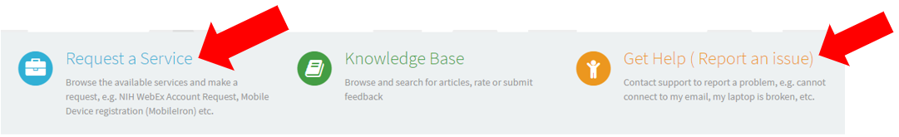

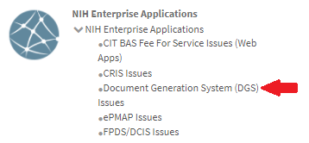
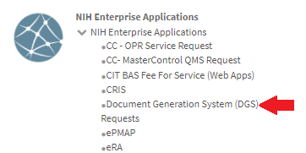
Step 4: Once, you select ‘Request for Service’ or ‘Report an issue’ proceed to select ‘NIH Enterprise Application’ and choose ‘Document Generation System (DGS) Request or Report.’

